ASSIGNMENT

Q1. Explore the search space diagram for the tic-tac toe game .Solve using minmax algorithm to find the optimal path where the max would win. Assumption: Selection of appropriate value of utility numbers and begin with the max player

.

Q2. Each letter is one digit integer 0,1,2 to 9, each having a different value. What are the values of each of the letters? Solve to make your agent rationally think in terms of domains and variables as well.

SEND

+MORE

------------

MONEY

Q3 . Solve the game tree using alpha-beta pruning algorithm. Evaluate the respective utility number at the root of the game tree.

. 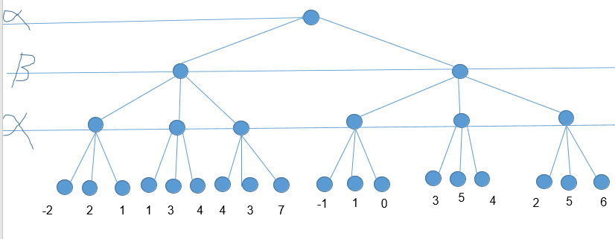

Q4. Given an undirected graph and a number m, determine if the graph can be coloured with at most 3colours such that no two adjacent vertices of the graph are colored with the same color. Here coloring of a graph means the assignment of colors to all vertices. (use backtrack)

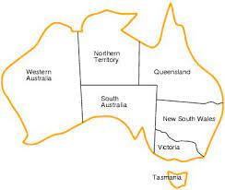

Q5. Solve the N-Queens problem using Genetic Algorithm.